**Tugas 03 Praktikum Basis Data**



Dibuat Oleh :

Nashirudin Baqiy

24060119130045

Asisten Praktikum :

Fauzan Idal Fithri El-Ardhi

Ines Adhisti Putri Pertiwi

**DEPARTEMEN INFORMATIKA**

**FAKULTAS SAINS DAN MATEMATIKA**

**UNVERSITAS DIPONEGORO**

**2020**

SOAL

Dari ERD yang dihasilkan pada praktikum sebelumnya (modul 3), rancanglah semua tabel yang terjadi, Lengkapi dengan tipe data pada masing-masing atribut dan constrain –constrainnya jika ada.

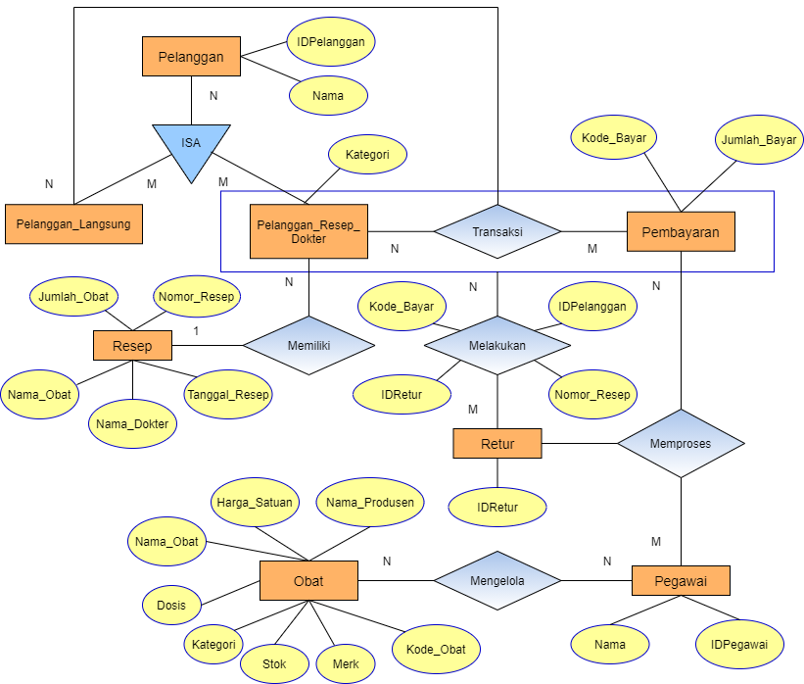

**PELANGGAN**

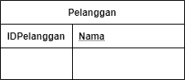

|  |  |  |
| --- | --- | --- |
| Nama Atribut | Tipe Data | Constraint |
| IDPelanggan | INT(15) | NOT NULL, PRIMARY KEY |
| Nama | VARCHAR(50) | NOT NULL |

**PELANGGAN_LANGSUNG**

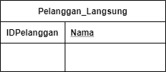

|  |  |  |
| --- | --- | --- |
| Nama Atribut | Tipe Data | Constraint |
| IDPelanggan | INT(15) | FOREIGN KEY |
| Nama | VARCHAR(50) | FOREIGN KEY |

**PELANGGAN_RESEP_DOKTER**

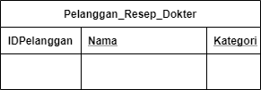

|  |  |  |
| --- | --- | --- |
| Nama Atribut | Tipe Data | Constraint |
| IDPelanggan | INT(15) | FOREIGN KEY |
| Nama | VARCHAR(50) | FOREIGN KEY |
| Kategori | INT(1) | NOT NULL, UNIQUE |

**RESEP**

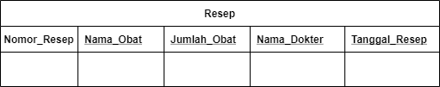

|  |  |  |
| --- | --- | --- |
| Nama Atribut | Tipe Data | Constraint |
| Nomor_Resep | INT(10) | NOT NULL, PRIMARY KEY |
| Nama_Obat | VARCHAR(25) | NOT NULL |
| Jumlah_Obat | INT(5) | NOT NULL |
| Nama_Dokter | VARCHAR(50) | NOT NULL |
| Tanggal_Resep | DATE | NOT NULL |

**PEMBAYARAN**

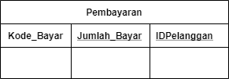

|  |  |  |
| --- | --- | --- |
| Nama Atribut | Tipe Data | Constraint |
| Kode_Bayar | INT(10) | NOT NULL, PRIMARY KEY |
| Jumlah_Bayar | INT(5) | NOT NULL |
| IDPelanggan | INT(15) | FOREIGN KEY |

**RETUR**

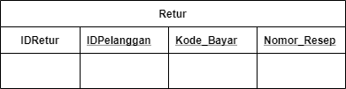

|  |  |  |
| --- | --- | --- |
| Nama Atribut | Tipe Data | Constraint |
| IDRetur | INT(10) | NOT NULL, PRIMARY KEY |
| IDPelanggan | INT(15) | FOREIGN KEY |
| Kode_Bayar | INT(10) | FOREIGN KEY |
| Nomor_Resep | INT(10) | FOREIGN KEY |

**PEGAWAI**

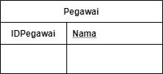

|  |  |  |
| --- | --- | --- |
| Nama Atribut | Tipe Data | Constraint |
| IDPegawai | INT(10) | NOT NULL, PRIMARY KEY |
| Nama | VARCHAR(50) | NOT NULL |

**OBAT**

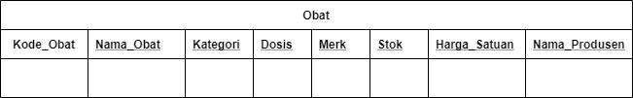

|  |  |  |
| --- | --- | --- |
| Nama Atribut | Tipe Data | Constraint |
| Kode_Obat | INT(10) | NOT NULL, PRIMARY KEY |
| Nama_Obat | VARCHAR(25) | NOT NULL |
| Kategori | VARCHAR(5) | NOT NULL |
| Dosis | VARCHAR(10) | NOT NULL |
| Merk | VARCHAR(25) | NOT NULL |
| Stok | INT(10) | NOT NULL |
| Harga_Satuan | INT(10) | NOT NULL |
| Nama_Produsen | VARCHAR(50) | NOT NULL |